WEEK 1 | ACTIVITY PROGRAMME
DAY 1  Monday | PLYMOUTH ORIENTATION  Students are given the opportunity to explore the city, find their bearings, and practice their language skill as they complete an orientation activity. | 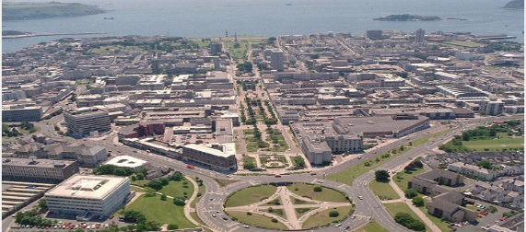
DAY 2  Tuesday | INDOOR SPORTS AT PLYMOUTH LIFE CENTRE  An active afternoon of sport is on the agenda this afternoon. Play a game of badminton or squash within the Plymouth life centre.  https://www.everyoneactive.com/centre/plymouth-life-centre/ | 
DAY 3  Wednesday | PLYMOUTH HARBOUR BOAT TRIP  Explore the historic city. Visit the waterfront. The historic Barbican and The Hoe. Take a guided cruise of the harbour.  Harbour boat cruise.  http://www.plymouthboattrips.co.uk/ | 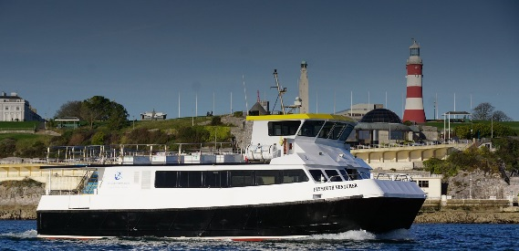
DAY 4  Thursday | GEOCACHING IN PLYMOUTH  Get ready to join the world’s largest Treasure hunt as you use smartphones to locate Geocaches around the city. Try not to get too side-tracked by Primark and Poundland!  https://www.geocaching.com/play | 
DAY 5  Friday | PLYMOUTH TOURISM PROJECT (DAY 1)  Working in groups students are tasked with creating a tourist publicity campaign for Plymouth. Finish the afternoon with a ride on the popular land-train.  http://www.visitplymouth.co.uk/things-to-do/plymouth-land-train-p2032403 | 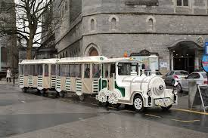
DAY 6  Saturday | FULL DAY EXCURSION The Eden Project  Visit Eden, an impressive Eco attraction in spectacular biomes. Including an interactive work-shop on Sustainability.  Looe  Explore a charming Cornish harbour.  http://www.edenproject.com/ | 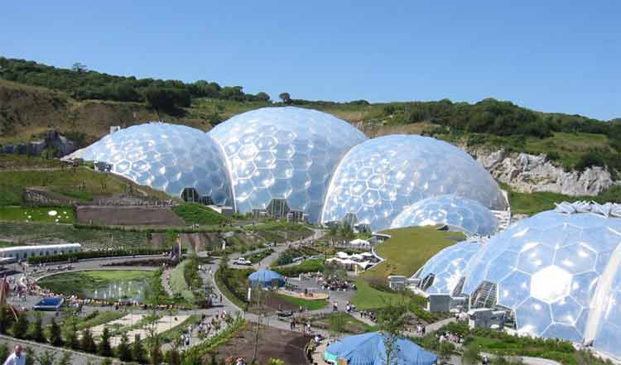
DAY 7  Sunday | DAY SPENT WITH FAMILIES

WEEK 2 | ACTIVITY PROGRAMME
DAY 1  Monday | SMEATON’S TOWER & MAYFLOWER MUSEUM  Experience the history of the city this afternoon. Marvel at the panoramic view from the top of Smeaton’s Tower and then learn about Plymouth’s maritime past at the Mayflower Museum.  https://plymhearts.org/smeatons-tower/ | 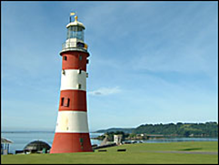
DAY 2  Tuesday | PLYMOUTH TOURISM PROJECT (DAY 2)  Working in groups students are tasked with creating a tourist publicity campaign for Plymouth. Prizes will be awarded to groups in follow-up / presentation lesson. | 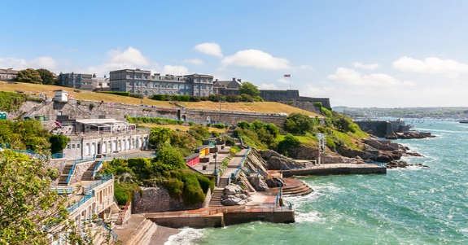
DAY 3  Wednesday | MOUNT EDGECUMBE HOUSE  Take the historical Cremyll ferry to visit a traditional English house and garden.  http://www.plymouthboattrips.co.uk/ferries/cremyll-ferry/  http://www.mountedgcumbe.gov.uk/ | 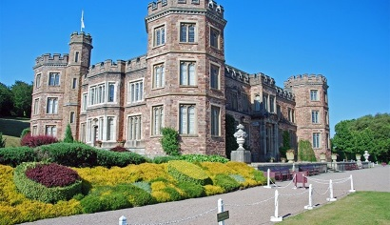
DAY 4  Thursday | ESCAPE ROOMS PLYMOUTH –  Put your team building and critical thinking skills to the test, as in groups you aim to solve the clues - Will your group escape in time?  http://www.escaperoomsplymouth.co.uk/ | 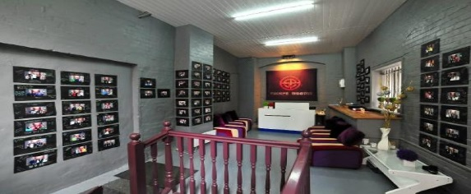
DAY 5  Friday | TINSIDE LIDO  Voted as one of the top 10 outdoor pools in Europe, Tinside Lido is an attraction not to be missed. Swim, chill-out and enjoy!  https://www.everyoneactive.com/centre/tinside-lido/ | 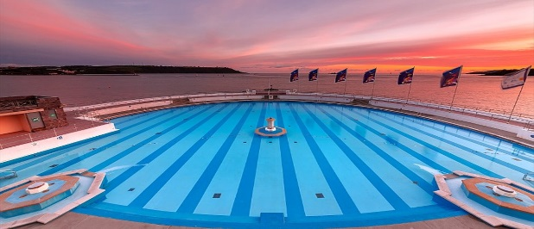
DAY 6  Saturday | FULL DAY EXCURSION Exeter  Visit the charming cathedral city of Exeter. Include a visit to the Cathedral and the impressive Royal Albert Museum, where you can even stand on a Roman Wall!  https://www.rammuseum.org.uk/ | 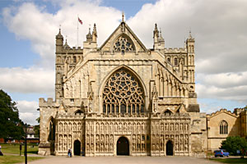
DAY 7  Sunday | RETURN
The following EVENING ACTIVITIES are provided during the 2 week programme.

TEN PIN BOWLING  Strike? Spare? Which student will be Kingpin as we enjoy an evening of Bowling fun at https://www.tenpin.co.uk/our-locations/plymouth-barbican/ |  | 
ICE DISCO at Plymouth Pavilions.  A chance for students to demonstrate their ice skating moves on the Ice rink. Students always enjoy this opportunity to let their hair down! https://www.plymouthice.co.uk/Online/ |  | 

Extra evening activities can be arranged for additional cost.
Karaoke.
Cinema night.
Pizza Party.
Talent Contest.

